Ludek KOLESA
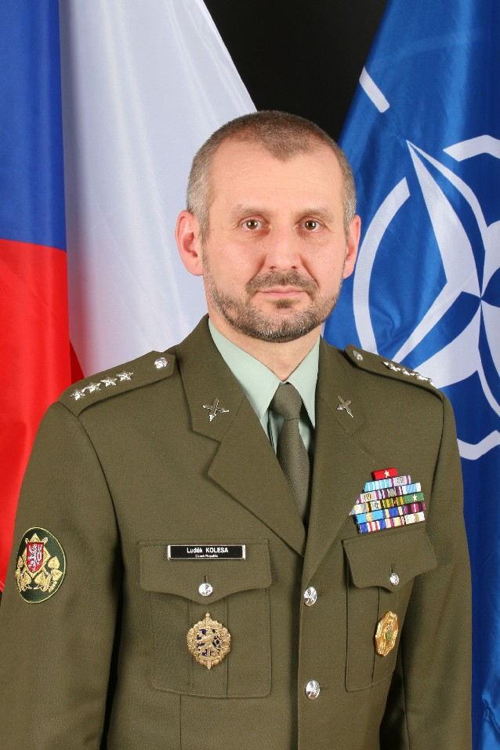
Command Sergeant Major of
the Armed Forces of the Czech Republic
Ludek KOLESA was born in Litomerice on 14th December 1961. Following Primary and Secondary school, he attended the Chemical Technology High School until he began four years of study at the Charles University in Prague, earning a BA degree from the Natural Science Faculty in 1985. During his university years he also completed a 2-year course for infantry platoon leaders.

He served as an enlisted soldier from 1985 to 1987 before being employed as an MoD civilian until 1994. He served a nine-month operational tour during the Balkan wars in the former Yugoslavia, as a member of the European Community Monitoring Mission (ECMM).

In April 1994, he re-joined the Army as a Staff Sergeant at the MoD Foreign Relations Directorate. Between April 1994 and May 1995, he served in the United Nations Guard Contingent in Iraq (UNGCI). During this 13-month period he was appointed Mobile Team Leader and later Operations Officer of Erbil Sector. CSM KOLESA personally led UNGCI teams during two operations rescuing personnel of several non-governmental and international organizations in an area of serious fighting between Kurdish factions in Northern Iraq. Upon his return from Iraq he worked for several months in the Military Observers Office.

CSM KOLESA later served at the MoD Foreign Liaison Office as an Executive Assistant to the Director, and later as a Liaison Officer, prior to being selected to serve at NATO HQ Brussels as an Aide-de-Camp of the Military Representative of the Czech Republic to the NATO Military Committee. During his three-year tour of duty at NATO HQ (2000-2003), he was elected Secretary, and later President, of the NATO Aide-de-Camp Association.

On 1 August 2003, he was appointed as the first-ever Command Sergeant Major of the Armed Forces of the Czech Republic. He then helped design, and presided over, the re-vitalization of his military’s NCO Corps during a period of intense transformation and reform.

CSM Ludek KOLESA completed the American Language Course at the Defense Language Institute, Lackland AFB, Texas, and then Class 54 of the U.S. Army Sergeants Major Academy in Fort Bliss, Texas. He graduated in the top twenty percent of his class, and was awarded the “International Leadership Award” after being named the top international student of Class 54. In 2005, CSM KOLESA graduated from the BMATT Senior Sergeant Majors Course.

CSM KOLESA’s awards also include the Lone Star Distinguished Service Medal, the Medal For Service Abroad, Armed Forces of the Czech Republic Medal Grades III and II, the UN Special Service Medal, ECMM Medal, Service For Peace Medal, 50 years of NATO Medal, Premysl Otakar IInd, the Iron and Golden King Medal, UNGCI Mission Bar, U.S. Army NCO Professional Development Award, and The State of Texas Adjutant General’s Individual Award.

Ludek KOLESA is married to Pauliina KAVONIUS and lives in Prague. His main hobby is rock climbing and sports in general.

